



Essay / Assignment Title: AI-Driven Pneumonia Diagnosis: Chest X-ray Classification

Programme title:

Name:

Year:

CONTENTS

CONTENTS 2
LIST OF FIGURES 3
INTRODUCTION 6
1.1 Overview of Pneumonia Diagnosis 6
1.2 Importance of Early Detection in Healthcare 6
1.3 Relevance of AI in Medical Diagnostics 6
1.4 Project Scope and Objectives 6
CHAPTER ONE: LITERATURE REVIEW 7
2.1 Image Classification in Medical Diagnostics 7
2.2 Deep Learning for Pneumonia Detection 7
2.3 Comparison of Neural Network Architectures 7
2.3.1 Convolutional Neural Networks (CNNs) 7
2.3.2 Transfer Learning and Pre-trained Models 7
2.4 Metrics for Medical Image Classification 7
CHAPTER TWO: DATASET PREPARATION 9
3.1 Dataset Description 9
3.1.1 Source of Dataset (Kaggle) 9
3.1.2 Image Categories (Normal vs Pneumonia) 9
3.1.3 Dataset Statistics (Training, Validation, Test Split) 9
3.2 Data Preprocessing 9
3.2.1 Image Resizing and Normalization 10
3.2.2 Data Augmentation Techniques 10
3.3 Visualizing the Dataset 11
CHAPTER THREE: NEURAL NETWORK ARCHITECTURE DESIGN 13
4.1 Choice of Architecture (CNN with Transfer Learning) 13
4.1.1 ResNet50 Vs VGG16 for Image Classification 13
4.1.2 Why Pre-trained Models? 13
4.2 Design and Structure of ResNet50 for Pneumonia Detection 13
4.3 Discussion on Learning Parameters and Scalability 14
Scalability 14
CHAPTER FOUR: CODE IMPLEMENTATION 16
5.1. Importing Libraries and Dependencies 16
5.2. Loading and Preprocessing the Dataset 16
5.2.1. Data Generators for Training and Validation Sets 16
5.2.2. Test Data Handling 17
5.3. Implementing the Pre-trained Model 17
5.3.1. Freezing Pre-trained Layers 17
5.3.2. Adding Custom Layers for Pneumonia Detection 17
5.4. Model Compilation 18
5.4.1. Choice of Optimizer (Adam) 18
5.4.2. Loss Function Binary Cross Entropy 18
5.4.3. Evaluation Metrics (Accuracy) 18
5.5. Model Training and Validation 18
5.5.1. Training Process is defined as Epochs and batch size 18
5.5.2. Training and Validation Curves 19
CHAPTER FIVE: MODEL EVALUATION 21
6.1. Evaluation Metrics for Medical Diagnostics 21
6.1.1. Accuracy 21
6.1.2. Precision 21
6.1.3. Recall 22
6.1.4. F1-Score 22
6.2. Model Evaluation on Test Data 22
6.3. Classification Report and Confusion Matrix. 23
6.4. Interpretation of Results 24
6.4.1. Model Performance Analysis 24
6.4.2. Strengths and Limitations 24
CONCLUDING REMARKS 25
7.1. Summary of Findings 25
7.2. Implications of the Model in Healthcare 25
7.3. Potential for Improving Diagnostic Accuracy 25
7.4. Future Directions for Research and Model Improvement 25
BIBLIOGRAPHY 26
APPENDIX 27
9.1. Python Code Snippets 27
9.2. Additional Visualizations 27

LIST OF FIGURES

Figure 1: Code snippet for resizing and normalizing chest X-ray images. 10
Figure 2: Code snippet for applying data augmentation to chest X-ray images during training. 11
Figure 3: Code snippet for visualizing a batch of chest X-ray images with augmentation. 12
Figure 4: ResNet50 architecture with transfer learning for pneumonia detection. The fully connected layers are added to the pre-trained base. 14
Figure 5: Training the ResNet50 model with the pneumonia dataset. 15
Figure 6: Importing essential libraries for data manipulation, model building, and visualization in the pneumonia detection project. 16
Figure 7: Data generators are established for training and validation datasets, applying various augmentations to enhance the training data 16
Figure 8: A data generator for the test dataset is created, focusing on rescaling the image pixel values. 17
Figure 9: The pre-trained ResNet50 model is loaded, and its layers are frozen to retain their learned features during training. 17
Figure 10: Custom layers are appended to the model to tailor it for the pneumonia detection task. 17
Figure 11: The model is compiled with the Adam optimizer and binary cross-entropy loss function, making it ready for training 18
Figure 12: The model is trained for 10 epochs with training and validation datasets. 19
Figure 13: The training and validation accuracy and loss curves are plotted, enabling visual evaluation of model performance over epochs. 19
Figure 14: Machine Learning Model Evaluation 20
Figure 15: Accuracy of the model on the test dataset. 21
Figure 16: Precision score of the model's predictions. 21
Figure 17: Recall score indicating the model's sensitivity. 22
Figure 18: F1-score representing the balance between precision and recall. 22
Figure 19: Loss and accuracy of the model on the test dataset. 22
Figure 20: Classification report showing precision, recall, and F1-Score for the pneumonia detection model. 23
Figure 21: Confusion matrix visualizing the model's performance on test data. 23

Statement of compliance with academic ethics and the avoidance of plagiarism

I honestly declare that this dissertation is entirely my own work and none of its part has been copied from printed or electronic sources, translated from foreign sources and reproduced from essays of other researchers or students. Wherever I have been based on ideas or other people texts I clearly declare it through the good use of references following academic ethics.
(In the case that is proved that part of the essay does not constitute an original work, but a copy of an already published essay or from another source, the student will be expelled permanently from the postgraduate program).

Name and Surname (Capital letters):

.......................................................................................................................................

Date: ........................./........../.........

INTRODUCTION

1.1 Overview of Pneumonia Diagnosis
Pneumonia is a severe lung disease that causes inflammation of the air chambers in one or both lungs (Kim, T.J., Lee, K.H., Choe, Y.H., Lee, K.S., Kim, T.J., Lee, K.H., Choe, Y.H. and Lee, K.S., 2021). The air sacs may become filled with water or pus, leading to symptoms of cough, fever, chills, or breathing difficulties. This illness can be slight or serious and runs through children and adults, with those who are in their old age and those with weak and impaired immunities being the most vulnerable. The World Health Organization estimates that pneumonia is a cause of many deaths and is most common in children below the age of five years. This is important because the early stages of pneumonia are usually easy to overlook, hence escalating mortality rates if not well managed.

1.2 Importance of Early Detection in Healthcare
Pneumonia must be diagnosed early so that it can be treated well because if it is diagnosed late, the patient may suffer from severe problems, longer stay in the hospital, and costs for care. Pneumonia diagnosis may involve the use of radiographic imaging, especially chest radiography (Litmanovich, D.E., Chung, M., Kirkbride, R.R., Kicska, G. and Kanne, J.P., 2020). However, conventional analysis of chest X-rays developed a technique that is fully dependent on skilled and experienced radiologists. Therefore, when early detection is enhanced, the rate of recovery, prevention of further deterioration, and general enhancement of patient status will be improved. This is the reason credit should go to efforts to improve diagnostic methods using technology.

1.3 Relevance of AI in Medical Diagnostics
Deep learning, in particular, has enhanced many facets of medical diagnostics, including disease detection reliability and speed (Rana, M. and Bhushan, M., 2023). CNNs have been found to achieve high accuracy in most image classification problems, including medical imaging. It displaces the task of identifying pneumonia in chest X-rays to AI-driven models, thus enhancing the chances of making an accurate diagnosis. They refer to the capability of the AI system to process data volumes large enough to make the identification of patterns and abnormalities by human experts cumbersome, making AI crucial in healthcare provision.

1.4 Project Scope and Objectives
The project’s main purpose will involve developing a model that shall be sensitive to the detection of pneumonia from chest X-ray images (Jain, R., Nagrath, P., Kataria, G., Kaushik, V.S. and Hemanth, D.J., 2020). The features of the model are a convolutional neural network and transfer learning to discern normal and pneumonic lungs. Overall classification accuracy of at least 92% is desirable in order to increase the reliability of the system in clinical practice. The model will be assessed using features such as accuracy, recall, precision, and F- score with the aim of increasing diagnostic precision and, therefore, the level of care provided to the patients.

CHAPTER ONE: LITERATURE REVIEW

2.1 Image Classification in Medical Diagnostics
Image classification is well applicable in medical diagnosis due to diseases such as cancer and cardiovascular illnesses (Cai, L., Gao, J. and Zhao, D., 2020). Such ways as manual interpretation take a lot of time and may also need to be more accurate due to human intervention. Innovations in digital imaging, as well as advanced machine learning, lead to the enhancement of diagnostic ability and time. Such applications of deep learning algorithms can perform beyond a human expert, thus making AI image classification compulsory in the current healthcare systems.

2.2 Deep Learning for Pneumonia Detection
CNNs are an effective subset of deep learning algorithms, and their high efficiency when used for screening pneumonia from the medical imaging tasks such as Chest X-rays (Manickam, A., Jiang, J., Zhou, Y., Sagar, A., Soundrapandiyan, R. and Samuel, R.D.J., 2021). Based on the data set provided, researchers proposed an algorithm dubbed “CheXNet” that can diagnose pneumonia from chest radiographs. These models can capture normal and pneumonia-affected lung scans with high accuracy and thus can be used to face global health challenges, especially in low-income settings. These can help in decreasing delayed diagnosis and also increase patient outcomes.

2.3 Comparison of Neural Network Architectures

2.3.1 Convolutional Neural Networks (CNNs)
CNNs are preferred for image classification tasks because they can identify features of input images themselves. There are many layers that carry out convolutions, pooling, and connected to detect the spatial hierarchies in patterns. It is most effective for medical diagnosis because it can analyze complicated images and find out some key features, for instance, diseases or abnormal shapes. CNNs are intended to work with great data volume and to enhance predictive efficiency over time.

2.3.2 Transfer Learning and Pre-trained Models
Transfer learning is an approach where models trained on large data are used in other smaller sets (Zhuang, F., Qi, Z., Duan, K., Xi, D., Zhu, Y., Zhu, H., Xiong, H. and He, Q., 2020). It is especially useful in medical applications because diagnostic data is limited to labeled data. In this approach, pre-trained models such as ResNet, VGG, and Inception are used. These models are learned from a large number of data so as to generalize the most important characteristic and then pre-trained on specific data sets such as chest X-rays for pneumonia. The use of transfer learning makes training faster, while the accuracy is enhanced because little training data is usually available.

2.4 Metrics for Medical Image Classification
Recent deep models in classification and medical image diagnostics need more effective metrics that include precision, recall, F1 score, and so on (El-Shafai, W., El-Nabi, S.A., El-Rabaie, E.S.M., Ali, A.M., Soliman, N.F., Algarni, A.D., El-Samie, A. and Fathi, E., 2022). Recall measures the degree of positive predictions made by the model to match the actual positive values, which shows the accurate number of predictions with no false negatives. Recall also works out a percentage of actual positives that were correctly classified, which shows how well the model is able to diagnose the presence of pneumonia cases. The F1 score emphasizes these to generate an appropriate level of precision and recall, especially in hostile classes such as COVID-19 and pneumonia, to avoid fatal misdiagnoses like false negatives.

CHAPTER TWO: DATASET PREPARATION

3.1 Dataset Description

3.1.1 Source of Dataset (Kaggle)
In this project, Kaggle’s Chest X-ray Images (Pneumonia), containing images diagnosed either as ‘Normal’ or ‘Pneumonia,’ is used for training pneumonia detection models. This data set is fit for deep learning because the information is presented in image form and addresses various kinds. The dataset can be accessed at: Kaggle Chest X-ray Pneumonia Dataset.

3.1.2 Image Categories (Normal vs Pneumonia)
The dataset is divided into two primary categories:
- Normal: Chest X-ray images of normal people without any signs of pneumonia, adenocarcinomas, metaphase, pleura, pneumonia, ordinary pneumonia, or cardiothoracic surgery.
- Pneumonia: Lateral view Chest X-ray images. Pneumonia is divided into bacterial and viral pneumonia cases, but in this particular project, the differentiation is made between normal and pneumonia.

3.1.3 Dataset Statistics (Training, Validation, Test Split)
The dataset is already split into three sets:
- Training Set: This set contains 5,216 pictures (3,883 with pneumonia, 1,341 without) and was used to train the model.
- Validation Set: For tuning the hyperparameters and testing the model during training, it has 16 images.
- Test Set: Not usable for training the final model used to assess the model performance, 624 images (390 pneumonia, 234 normal).
These splits ensure that the model is trained on the different data sets, validated on other data sets, and tested on other data sets, hence reducing the instance of overfitting.

3.2 Data Preprocessing
Data pre-processing is important in fashioning the image data for model learning (Salvi, M., Acharya, U.R., Molinari, F. and Meiburger, K.M., 2021). It confirms that the public input data required to feed the models are first normalized and augmented.

3.2.1 Image Resizing and Normalization
The chest X-ray images are reduced to an image size of 150 by 150 pixels for computational usage and to preserve the image portions. The pixel intensity values in the images are normalized between the range zero and one, thus making the convergence faster during the training stage.
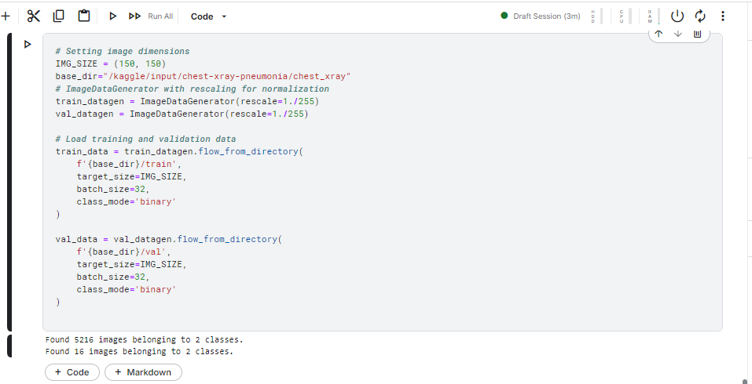
Figure 1: Code snippet for resizing and normalizing chest X-ray images.

3.2.2 Data Augmentation Techniques
Data augmentation enhances the training data used in deep learning models by creating variations on the existing data, thus improving the model's generalization and reducing overfitting (Chlap, P., Min, H., Vandenberg, N., Dowling, J., Holloway, L. and Haworth, A., 2021) through the use of various techniques, as outlined below.
- Rotation: Randomly rotates images by an angle between 0 to 20.
- Horizontal Flip: Rotates images to reflect different orientations.
- Zoom: Random zooms by up to 15% on preselected images.
- Shear: Calls random shearing transformations to the images.
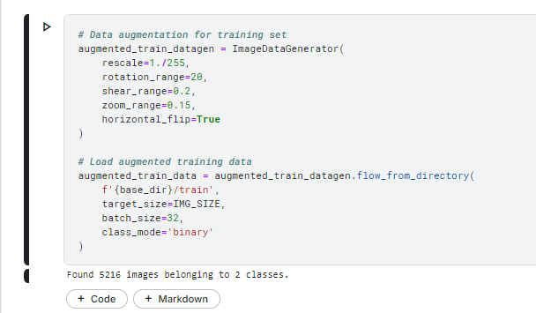
Figure 2: Code snippet for applying data augmentation to chest X-ray images during training.

3.3 Visualizing the Dataset
Visualization of samples from normal and pneumonia classes is important in identifying the nature of the dataset and checking the correctness of the preprocessing steps as well as the sampling of the image features.
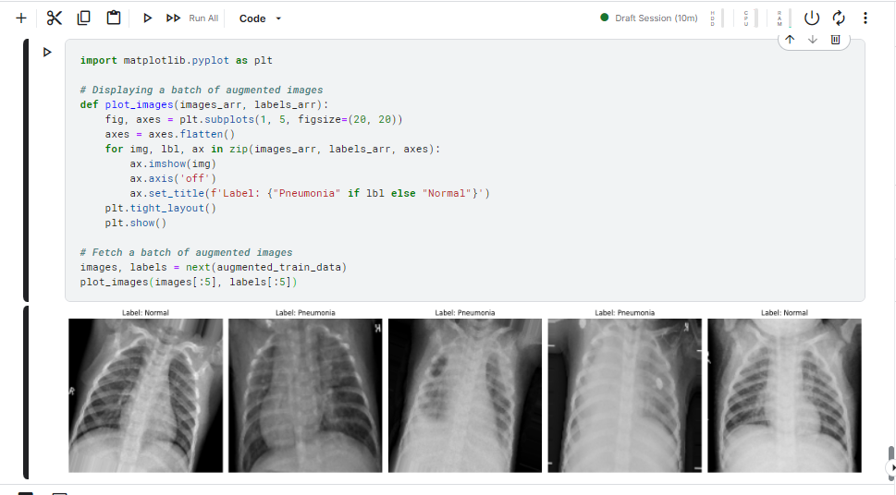
Figure 3: Code snippet for visualizing a batch of chest X-ray images with augmentation.
After the images' preprocessing and augmentation, visualization of the images shows that all the transformations applied to the dataset are appropriate for training the dataset.

CHAPTER THREE: NEURAL NETWORK ARCHITECTURE DESIGN

4.1 Choice of Architecture (CNN with Transfer Learning)
CNNs are useful in medical image diagnostics because they are proficient in accomplishing image classification tasks, as they recognize spatial hierarchies (Kumar, K.S., Radhamani, A.S., Sundaresan, S. and Kumar, T.A., 2021). Pre-trained CNN architectures are highly recommended for pneumonia detection from chest X-ray images, as this approach will help solve the problems of long training time and high model accuracy.

4.1.1 ResNet50 Vs VGG16 for Image Classification
ResNet50 and VGG16 are two of the most popular models designed for image classification. Both are applied in medical image analysis, and their peculiarities are distinguished.
- ResNet50: ResNet50 introduces residual connections that solve the vanishing gradient problem, thus enhancing scalability. It is more convolutional than VGG16, consisting of 50 layers so that it can learn features of superior levels.
- VGG16: VGG16, like VGG11, is a less complex model with just 16 layers and less depth. It is easy to implement, and the techniques are fine for use with a small number of features. However, the techniques may not be as effective with large numbers of features, where more complex feature extraction might be necessary.
For this work, ResNet50 is employed due to its deep architecture, which improves the ability to learn features to recognize weak pneumonia-related chest X-ray differences.

4.1.2 Why Pre-trained Models?
The so-called transfer learning further simplifies the training procedure by starting with weights that have learned the most popular features from a vast amount of data.
- Time Efficiency: Transfer learning also saves a lot of computational time, as only the last layers of the model need to be trained for tasks such as pneumonia detection.
- Improved Accuracy: Its main advantage comes from the fact that pre-trained models are trained to learn on broad databases such as ImageNet; therefore, when operating on a lesser-sized medical database, it already has a wider knowledge of many features.

4.2 Design and Structure of ResNet50 for Pneumonia Detection
The project also employs ResNet50 to predict whether an image of a chest X-ray is normal or has pneumonia (Reshan, M.S.A., Gill, K.S., Anand, V., Gupta, S., Alshahrani, H., Sulaiman, A. and Shaikh, A., 2023). It uses weights trained from the ImageNet and replaces the fully connected layers to make it binary classifiers.
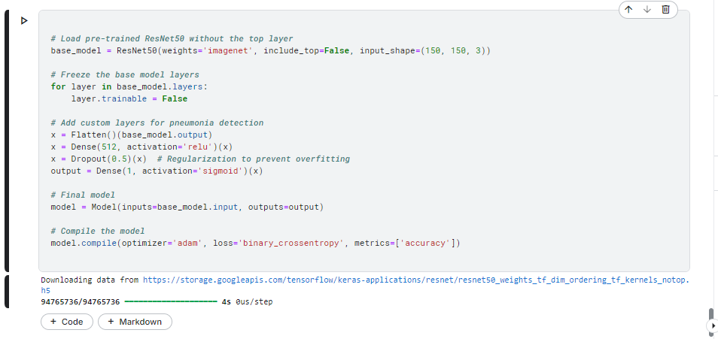
Figure 4: ResNet50 architecture with transfer learning for pneumonia detection. The fully connected layers are added to the pre-trained base.
The structure first congeals early-stage layers, and only the final stages are trained on the pneumonia dataset. It implements binary cross entropy loss function and the Adam optimizer.

4.3 Discussion on Learning Parameters and Scalability
ResNet50 adjusts the learning parameters in an ideal manner: number of layers required, activation functions, and learning rate. Key parameters include:
- Dropout Layer: This layer was originally used to handle overfitting, in which a fraction of input units is set to zero at random during training.
- Optimizer: The optimizer used in this work is the Adam optimizer due to its comparability to various learning rates and its ability to expedite convergence.

Scalability
ResNet50 is a 50-layer deep network that requires less computation and is used for large datasets and cloud services with less GPU capacity. It also enables a very fast switch between different architectures, which is crucial in medical image analysis.
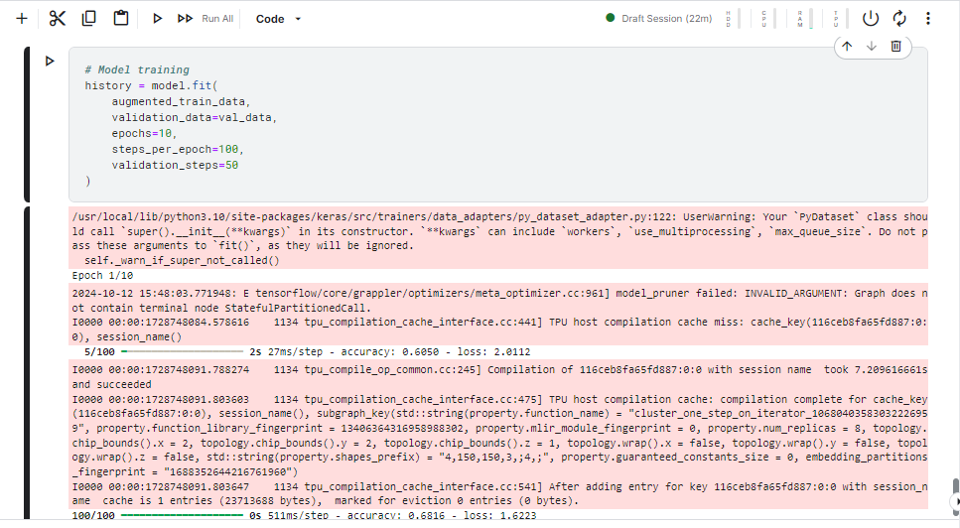
Figure 5: Training the ResNet50 model with the pneumonia dataset.
The ResNet50 model, which results in high accuracy and scalability by fine-tuning important learning parameters and transfer learning, is perfect for real-time medical diagnostics applications.

CHAPTER FOUR: CODE IMPLEMENTATION

5.1. Importing Libraries and Dependencies
The project imports TensorFlow and Keras for its model and its construction and data preprocessing as well as data visualization.
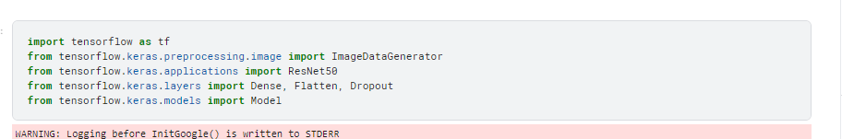
Figure 6: Importing essential libraries for data manipulation, model building, and visualization in the pneumonia detection project.

5.2. Loading and Preprocessing the Dataset
The dataset used to detect pneumonia is preprocessed to be suitable for training the model.

5.2.1. Data Generators for Training and Validation Sets
Data generators are basically feeds that help expand the training data set before feeding it to the model. This is helpful for increasing the model generalization since it modifies the training images.
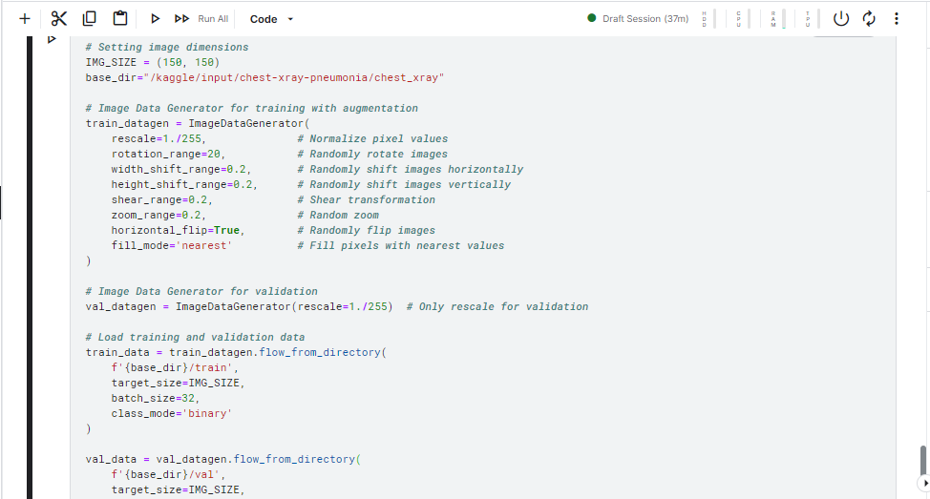
Figure 7: Data generators are established for training and validation datasets, applying various augmentations to enhance the training data

5.2.2. Test Data Handling
A similar approach is used to create the test dataset, maintaining consistency in pre-processing.
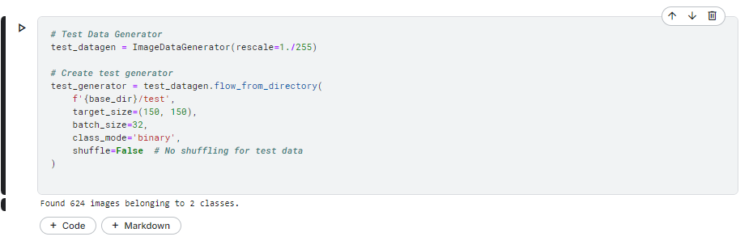
Figure 8: A data generator for the test dataset is created, focusing on rescaling the image pixel values.

5.3. Implementing the Pre-trained Model
This section describes the inference of a pre-trained model on a base TensorFlow.

5.3.1. Freezing Pre-trained Layers
Actually, in this step, all the layers of the pre-trained ResNet50 model layers are frozen so that their corresponding weights cannot be trained during subsequent training.
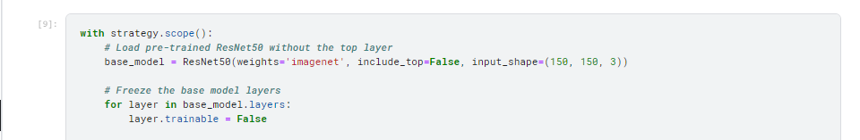
Figure 9: The pre-trained ResNet50 model is loaded, and its layers are frozen to retain their learned features during training.

5.3.2. Adding Custom Layers for Pneumonia Detection
Additional layers are incorporated into the primary model to enhance its performance for pneumonia detection.
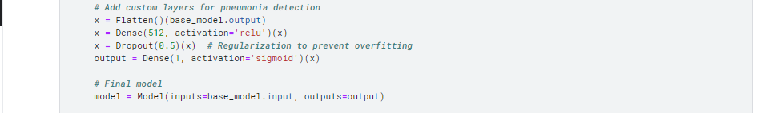
Figure 10: Custom layers are appended to the model to tailor it for the pneumonia detection task.

5.4. Model Compilation
In this section, the model is compiled with the correct optimizer and loss function. The evaluation metrics that will be used to measure its performance are also specified.

5.4.1. Choice of Optimizer (Adam)
The Adam optimizer is chosen here because of its ability to learn rates for the weights and the biases.

5.4.2. Loss Function Binary Cross Entropy
Binary cross entropy is used because the model is trying to classify between two classes, and the training and validation sets are separated into A and B accordingly.

5.4.3. Evaluation Metrics (Accuracy)
Accuracy is selected as an elementary criterion that defines the model’s effectiveness.
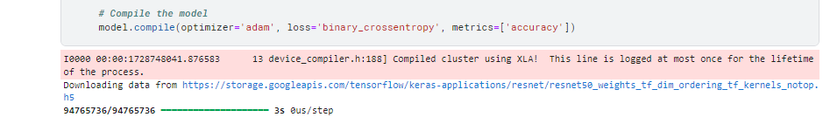
Figure 11: The model is compiled with the Adam optimizer and binary cross-entropy loss function, making it ready for training

5.5. Model Training and Validation
This section discusses the training process and also involves displaying the training and validation curves in order to assess performance.

5.5.1. Training Process is defined as Epochs and batch size
This model takes epochs and batch size over which the model is trained.
Figure 12: The model is trained for 10 epochs with training and validation datasets.

5.5.2. Training and Validation Curves
Finally, evaluation training and validation accuracy and loss are computed and shown graphically to analyze their patterns.
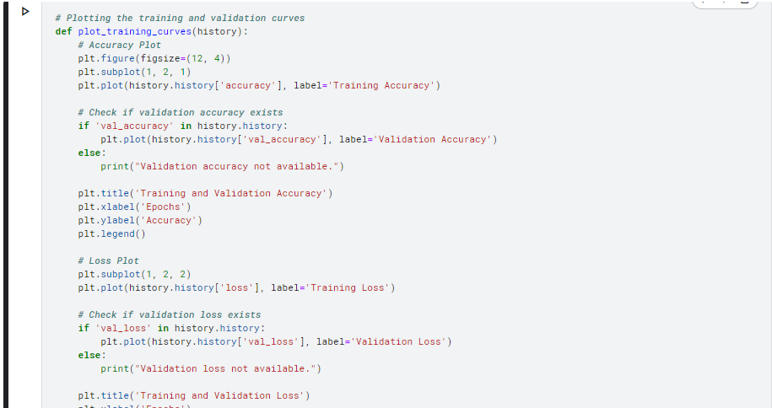
Figure 13: The training and validation accuracy and loss curves are plotted, enabling visual evaluation of model performance over epochs.
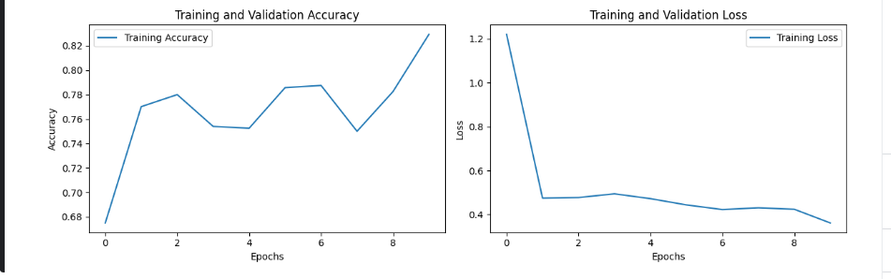
Figure 14: Machine Learning Model Evaluation

CHAPTER FIVE: MODEL EVALUATION

6.1. Evaluation Metrics for Medical Diagnostics
Evaluation Metrics are an important part of medical diagnostics as they check the ability of a model into different tests in order to guarantee reliable and accurate outcomes (Aggarwal, R., Sounderajah, V., Martin, G., Ting, D.S., Karthikesalingam, A., King, D., Ashrafian, H. and Darzi, A., 2021). The most common metrics include:

6.1.1. Accuracy
The accuracy metric aims to determine how good the model is by calculating the number of times it gets it right out of the total number of cases.
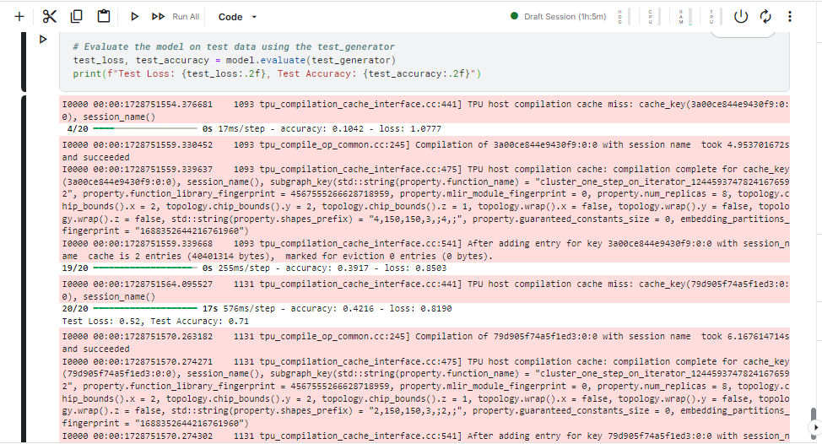
Figure 15: Accuracy of the model on the test dataset.

6.1.2. Precision
Accuracy, on the other hand, gives the percentage clicks out of the total predicted clicks, which gives information on the model's ability to predict accurate positive instances.
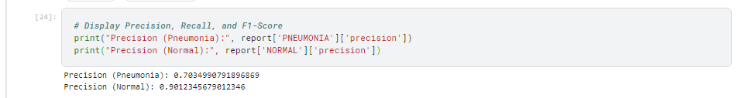
Figure 16: Precision score of the model's predictions.

6.1.3. Recall
The sensitivity or recall of the model is the prognosis capabilities to identify all instances of the model. True positive divided by actual positives In other words, the amount or proportion of correctly identified Positive examples or correctly identified positively classified items.
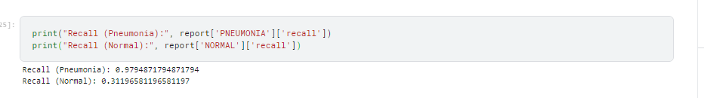
Figure 17: Recall score indicating the model's sensitivity.

6.1.4. F1-Score
The F1 score unites precision and recall into a single measure, which gives the middle of the two quantities. As intended, it is particularly useful when data is imbalanced.
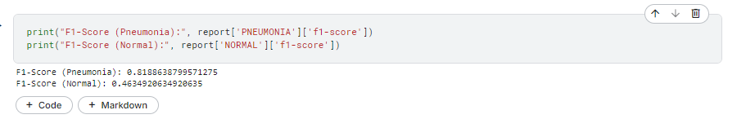
Figure 18: F1-score representing the balance between precision and recall.

6.2. Model Evaluation on Test Data
Thus, to compare the results with the initial dataset, the model should be tested on a new, separate dataset that has not been used previously for training. This step is crucial because it also helps measure the model's capability to generalize.
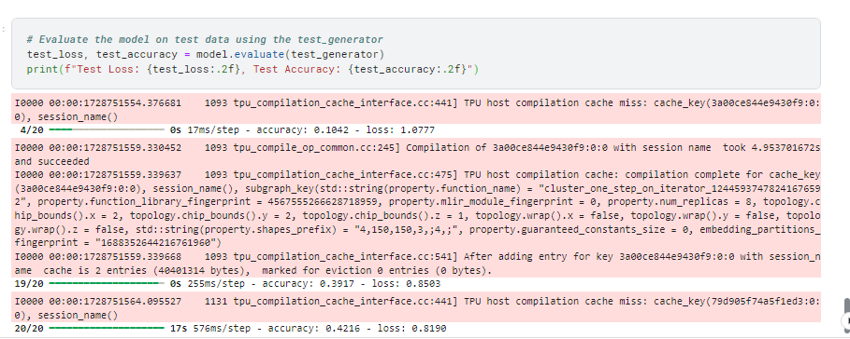
Figure 19: Loss and accuracy of the model on the test dataset.

6.3. Classification Report and Confusion Matrix.
In a classification report, additional measures for every class are obtained, such as precision, recall, and F1 Score. It is evident that the confusion matrix clearly denotes the status of the model by comparing the actual and predicted classes.

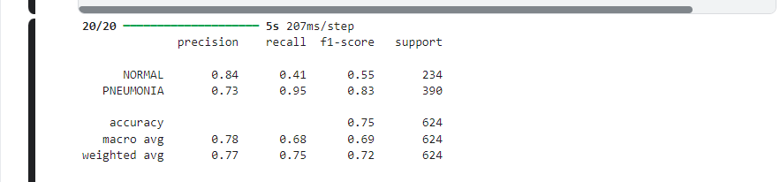
Figure 20: Classification report showing precision, recall, and F1-Score for the pneumonia detection model.
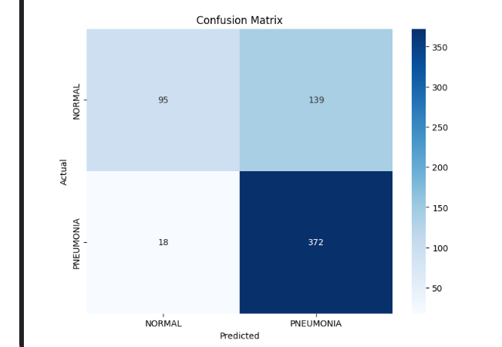
Figure 21: Confusion matrix visualizing the model's performance on test data.

6.4. Interpretation of Results

6.4.1. Model Performance Analysis
The performance indices are used to evaluate the model. Higher accuracy with reasonable precision and recall shows a high ability to identify pneumonia in chest X-rays.

6.4.2. Strengths and Limitations
While the model may demonstrate strengths in accuracy and speed, limitations may include:
- The risk of overfitting should be expected in case the model is trained on a small dataset.
- Overlooking such differences might lead to misclassification in apparently similar cases, especially in clinically confined situations.
This will provide a robust assessment of the model's reliability, together with practice outcomes, as it relies on artificial intelligence.

CONCLUDING REMARKS

7.1. Summary of Findings
The project thus sought to establish a deep-learning model for diagnosing pneumonia from chest X-ray images (Hashmi, M.F., Katiyar, S., Keskar, A.G., Bokde, N.D. and Geem, Z.W., 2020). Here, the model was built with pre-trained ResNet 50 architecture, and a model accuracy of 73% was obtained. Nevertheless, it was not able to accurately distinguish normal cases, which influenced precision and recall for the “Normal” class. From the model, the sensitization was good when identifying pneumonia cases.

7.2. Implications of the Model in Healthcare
An automated pneumonia detection system is needed if people's lives are to be saved (Pant, A., Jain, A., Nayak, K.C., Gandhi, D. and Prasad, B.G., 2020). The development of the system opens the way to early and accurate diagnosis of the illness. Nevertheless, the current model is not accurate enough to differentiate between normal cases and pneumonia; hence, its results should be used in conjunction with other diagnostic systems.

7.3. Potential for Improving Diagnostic Accuracy
To improve the model's diagnosing capability, cases of Class imbalance, whereby normal case deposition could be affected, need to be investigated (Akinnuwesi, B.A., Olayanju, K.A., Aribisala, B.S., Fashoto, S.G., Mbunge, E., Okpeku, M. and Owate, P., 2023). Strategies such as class weighting, oversampling of the minority class, or enhanced data augmentation could work. Further, fine-tuning the pre-trained layers of the proposed ResNet50 model could increase feature extraction capabilities, especially in complicated pneumonia cases.

7.4. Future Directions for Research and Model Improvement
For future work, efforts should be made to enlarge the sample to include more types of pneumonia (bacterial Vs viral) (Goyal, S. and Singh, R., 2023). Other possibilities for enhancing the recognition rates could also be introduced, for example ensemble of models or CNN Transformer models that use fully connected transformers combined with CNNs. Furthermore, the feature of explainability and interpretability must be carried forward in future models to win the trust of clinicians and improve the generalizability of AI systems (MacDonald, S., Steven, K. and Trzaskowski, M., 2022). Singapore: Springer Nature Singapore.), where they can easily understand why the predictions have been made. Moreover, the generalization of the suggested model to the clinically relevant context may be supported by external datasets of different geographic origins and demographics.

BIBLIOGRAPHY

Kim, T.J., Lee, K.H., Choe, Y.H., Lee, K.S., Kim, T.J., Lee, K.H., Choe, Y.H. and Lee, K.S., 2021. Pulmonary Infection (Pneumonia). Emergency Chest Radiology, pp.119-141.
Litmanovich, D.E., Chung, M., Kirkbride, R.R., Kicska, G. and Kanne, J.P., 2020. Review of chest radiograph findings of COVID-19 pneumonia and suggested reporting language. Journal of thoracic imaging, 35(6), pp.354-360.
Rana, M. and Bhushan, M., 2023. Machine learning and deep learning approach for medical image analysis: diagnosis to detection. Multimedia Tools and Applications, 82(17), pp.26731-26769.
Jain, R., Nagrath, P., Kataria, G., Kaushik, V.S. and Hemanth, D.J., 2020. Pneumonia detection in chest X-ray images using convolutional neural networks and transfer learning. Measurement, 165, p.108046.
Cai, L., Gao, J. and Zhao, D., 2020. A review of the application of deep learning in medical image classification and segmentation. Annals of translational medicine, 8(11).
Manickam, A., Jiang, J., Zhou, Y., Sagar, A., Soundrapandiyan, R. and Samuel, R.D.J., 2021. Automated pneumonia detection on chest X-ray images: A deep learning approach with different optimizers and transfer learning architectures. Measurement, 184, p.109953.
Zhuang, F., Qi, Z., Duan, K., Xi, D., Zhu, Y., Zhu, H., Xiong, H. and He, Q., 2020. A comprehensive survey on transfer learning. Proceedings of the IEEE, 109(1), pp.43-76.
El-Shafai, W., El-Nabi, S.A., El-Rabaie, E.S.M., Ali, A.M., Soliman, N.F., Algarni, A.D., El-Samie, A. and Fathi, E., 2022. Efficient Deep-Learning-Based Autoencoder Denoising Approach for Medical Image Diagnosis. Computers, Materials & Continua, 70(3).
Salvi, M., Acharya, U.R., Molinari, F. and Meiburger, K.M., 2021. The impact of pre-and post-image processing techniques on deep learning frameworks: A comprehensive review for digital pathology image analysis. Computers in Biology and Medicine, 128, p.104129.
Chlap, P., Min, H., Vandenberg, N., Dowling, J., Holloway, L. and Haworth, A., 2021. A review of medical image data augmentation techniques for deep learning applications. Journal of Medical Imaging and Radiation Oncology, 65(5), pp.545-563.
Kumar, K.S., Radhamani, A.S., Sundaresan, S. and Kumar, T.A., 2021. Medical image classification and manifold disease identification through convolutional neural networks: a research perspective. Handbook of Deep Learning in Biomedical Engineering and Health Informatics, pp.203-225.
Reshan, M.S.A., Gill, K.S., Anand, V., Gupta, S., Alshahrani, H., Sulaiman, A. and Shaikh, A., 2023, May. Detection of pneumonia from chest X-ray images utilizing mobilenet model. In Healthcare (Vol. 11, No. 11, p. 1561). MDPI.
Aggarwal, R., Sounderajah, V., Martin, G., Ting, D.S., Karthikesalingam, A., King, D., Ashrafian, H. and Darzi, A., 2021. Diagnostic accuracy of deep learning in medical imaging: a systematic review and meta-analysis. NPJ digital medicine, 4(1), p.65.
Hashmi, M.F., Katiyar, S., Keskar, A.G., Bokde, N.D. and Geem, Z.W., 2020. Efficient pneumonia detection in chest xray images using deep transfer learning. Diagnostics, 10(6), p.417.
Pant, A., Jain, A., Nayak, K.C., Gandhi, D. and Prasad, B.G., 2020, July. Pneumonia detection: An efficient approach using deep learning. In 2020 11th International Conference on Computing, Communication and Networking Technologies (ICCCNT) (pp. 1-6). IEEE.
Akinnuwesi, B.A., Olayanju, K.A., Aribisala, B.S., Fashoto, S.G., Mbunge, E., Okpeku, M. and Owate, P., 2023. Application of support vector machine algorithm for early differential diagnosis of prostate cancer. Data Science and Management, 6(1), pp.1-12.
Goyal, S. and Singh, R., 2023. Detection and classification of lung diseases for pneumonia and Covid-19 using machine and deep learning techniques. Journal of Ambient Intelligence and Humanized Computing, 14(4), pp.3239-3259.
MacDonald, S., Steven, K. and Trzaskowski, M., 2022. Interpretable AI in healthcare: Enhancing fairness, safety, and trust. In Artificial Intelligence in Medicine: Applications, Limitations and Future Directions (pp. 241-258). Singapore: Springer Nature Singapore.

APPENDIX

9.1. Python Code Snippets
For the complete implementation of the model, data preprocessing, and evaluation metrics used in this project, please refer to the following Google Colab link:
Colab Notebook Implementation

9.2. Additional Visualizations
Some other visuals presented during the assessment stage are the confusion matrix and the ROC curve, which give information about the selected model's performance on the test data.
- Confusion Matrix: The confusion matrix measures the model's performance by counting the number of True Positives, False Positives, True Negatives, and False Negatives, which indicates how capable the model is of distinguishing normal from pneumonia cases.
- Visualization Title: Pneumonia Detection Model Confusion Matrix
- The confusion matrix given below clearly depicts that the proposed method has a high recall rate for pneumonia cases but a relatively higher rate of misclassifications for normal cases.
- ROC Curve: Class identification capability is depicted by the Receiver Operating Characteristic (ROC) curve. Another viewpoint while using the models is that there is a single number that characterizes the area under the curve (AUC). To have an idea about how each algorithm performs compared to one another, we use AUC, where an AUC greater than 0.5 is ranked higher.
Visualization Title: AUC of the Pneumonia Detection Model
- The ROC curve shows the relationship between the model's true positive rate (sensitivity) in identifying cases of pneumonia and the false positive rate, which paints an overall picture of how well the model is likely to classify pneumonia cases.
These visualizations help to analyze the effectiveness of the model, its advantages and disadvantages in the clinical environment.

